**TASK 2 –**

**Login or sign-up form for Intern Crowd.**

**Sign-up page:**

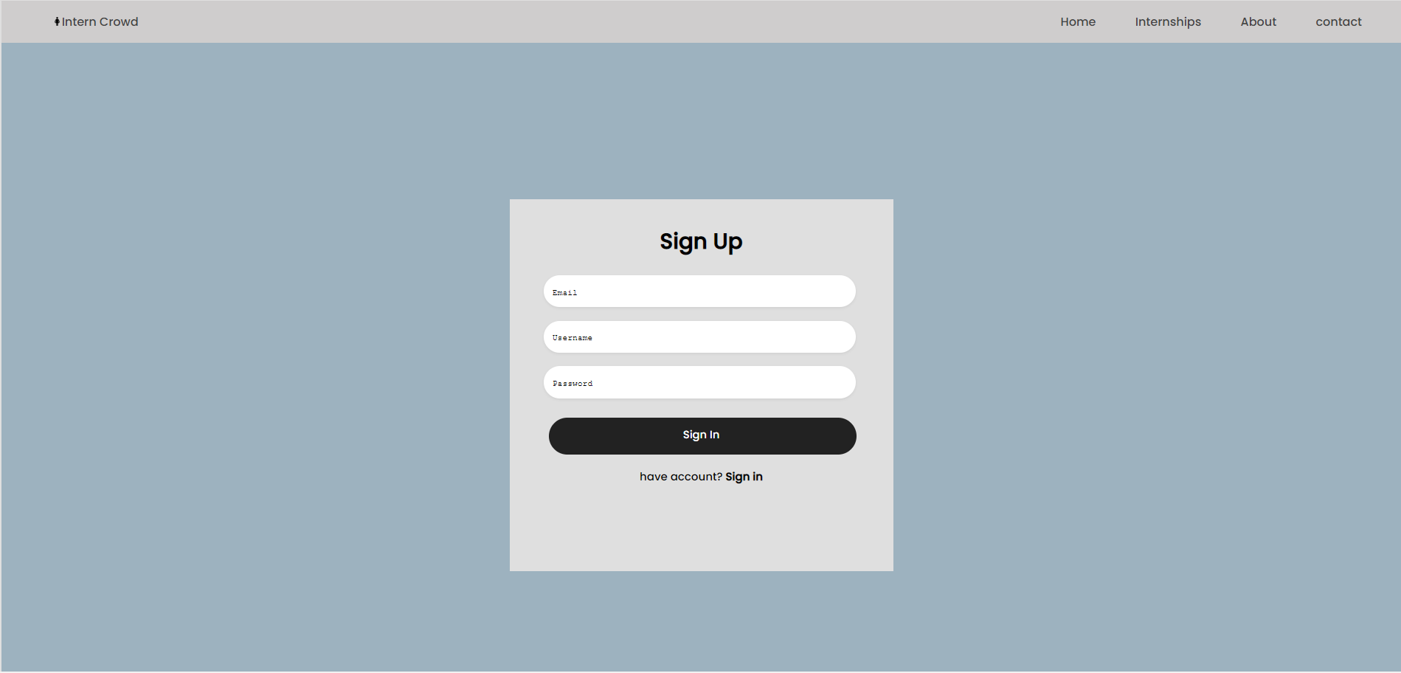

**Login/sign-in page:**

